**RTC Client Installation:**

<https://jazz.net/help-dev/clm/index.jsp?topic=%2Fcom.ibm.jazz.install.doc%2Ftopics%2Ft_client_installation.html>

**Installing the Rational Team Concert client in Eclipse by using the p2 installation repository**

<https://jazz.net/help-dev/clm/index.jsp?topic=%2Fcom.ibm.jazz.install.doc%2Ftopics%2Ft_client_installation.html>

Pre-requisites:

1. RTC server up and running
2. Eclipse version that supports the version of RTC.
3. Your existing Eclipse environment has a valid JVM that is ready to use.

The following setup is used for this document:

RTC server: 5.0.2

Eclipse: Juno SR2 64-bit(http://www.eclipse.org/downloads/packages/release/Juno/SR2)

Java: jdk 1.7 64-bit(<http://www.oracle.com/technetwork/java/javase/downloads/jre7-downloads-1880261.html>)

Download the P2 repository from <https://jazz.net/downloads/rational-team-concert/releases/5.0.2/RTC-Client-p2Repo-5.0.2.zip>

Extract the .zip file to a folder in local system.

Start Eclipse and select **Help > Install New Software.**

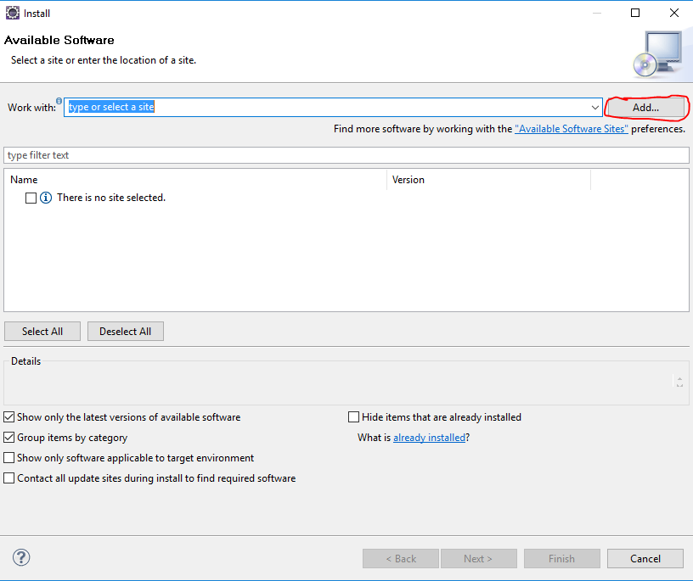

In the Available Software window, click **Add**. In the Add Repository window, click Archive and navigate to the p2 Install Repository .zip file that you downloaded. Click **OK.**

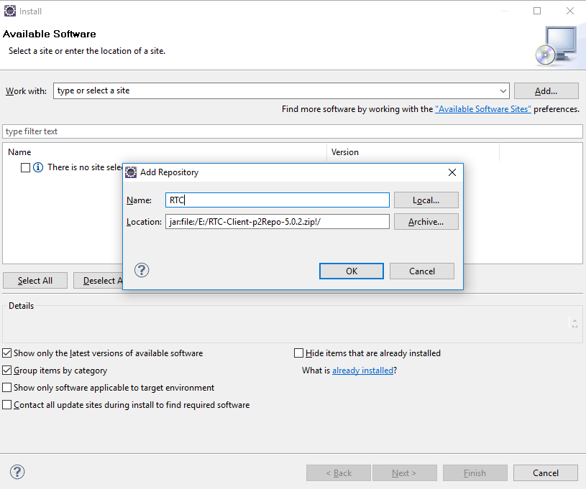

In the next window, ensure that **Group items by category** is selected. Select Rational Team Concert Client (extend an Eclipse installation)

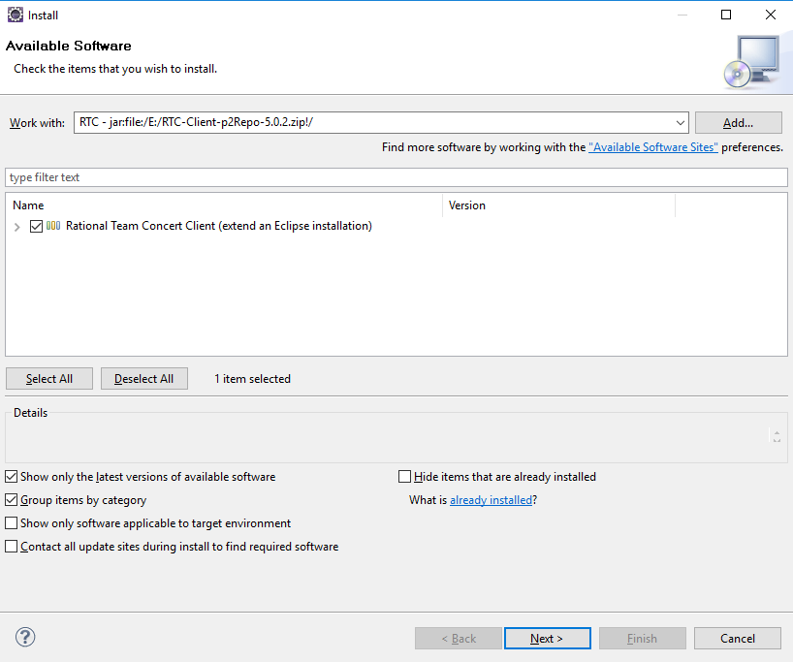

Click **Next**, then **Next** again in the Install Details window.

After you accept the terms of the license agreement, click **Finish**. A security warning window opens during the installation because the Rational Team Concert client bundles and features are not signed. Click **OK** to complete the installation. Click **Restart Now** when prompted to restart at the end of the installation.

Go to **Window>Open Perspective>Java**  to view all the tabs related to RTC.

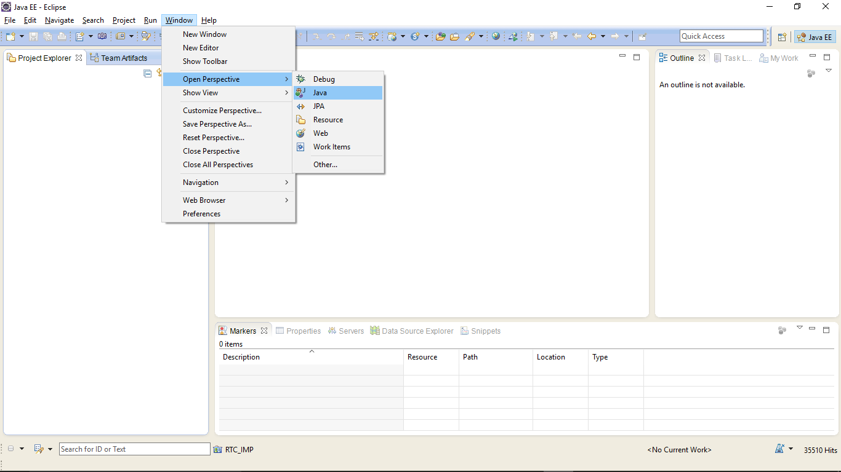

The screen appears as below with Team Artifacts view,My work, etc

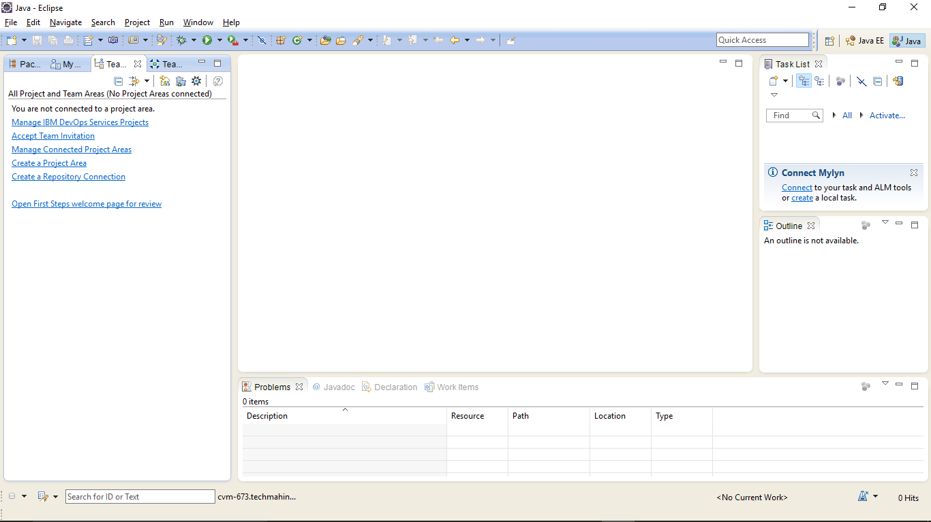

Click on **Create a Repository Connection** to connect to RTC server.

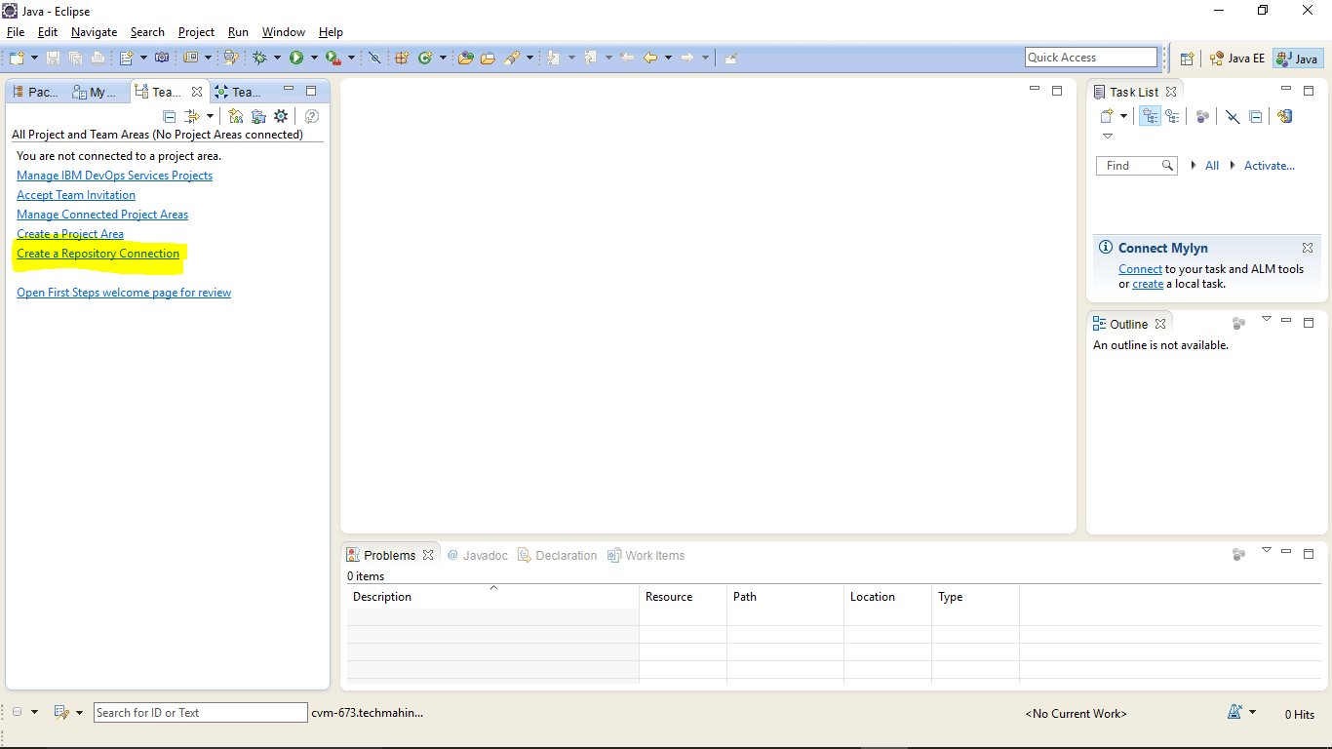

Provide the server url and credentials and click on **Finish**.

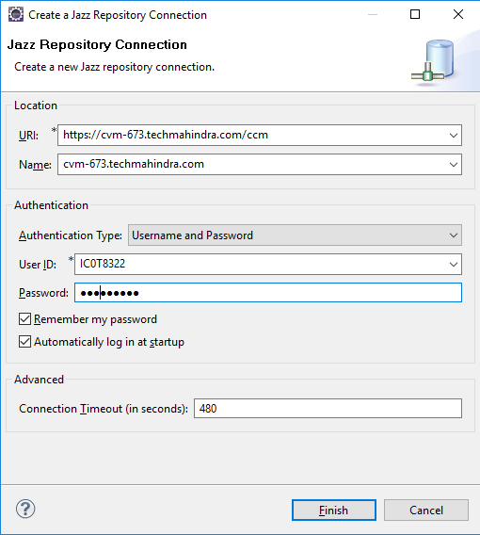

The repository connection will appear on the left. Right click on the connection and select **Manage Connected Project Areas.**

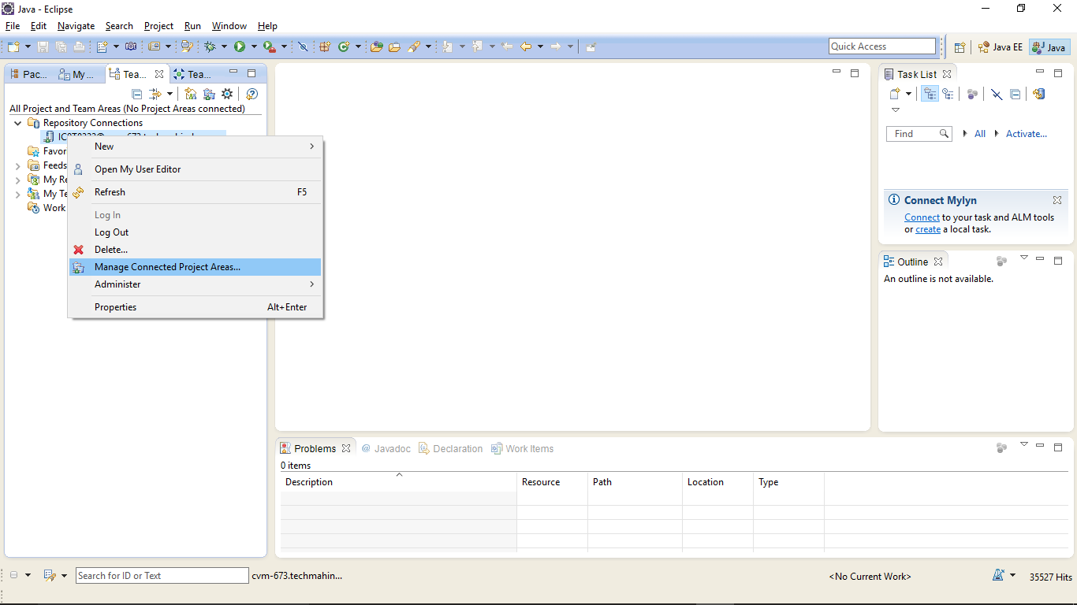

Select the project are you wish to connect and click **Finish**.

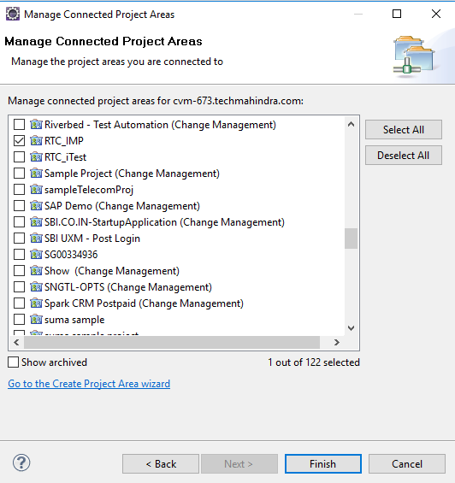

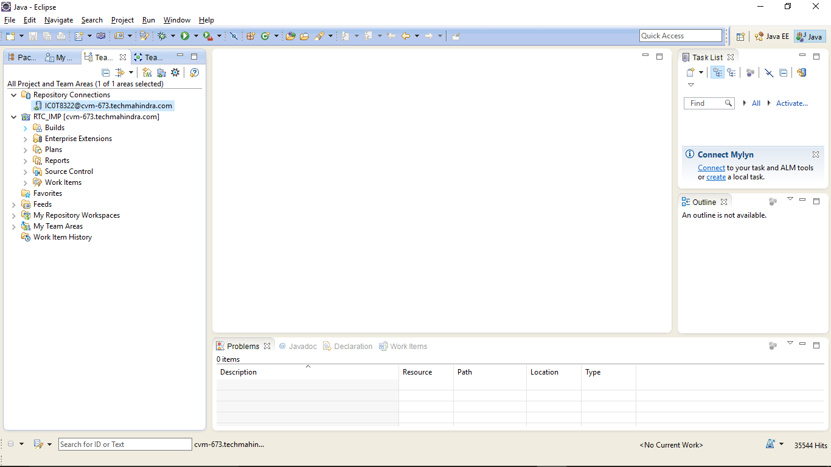

Right Click on the Project Area to view the configuration.

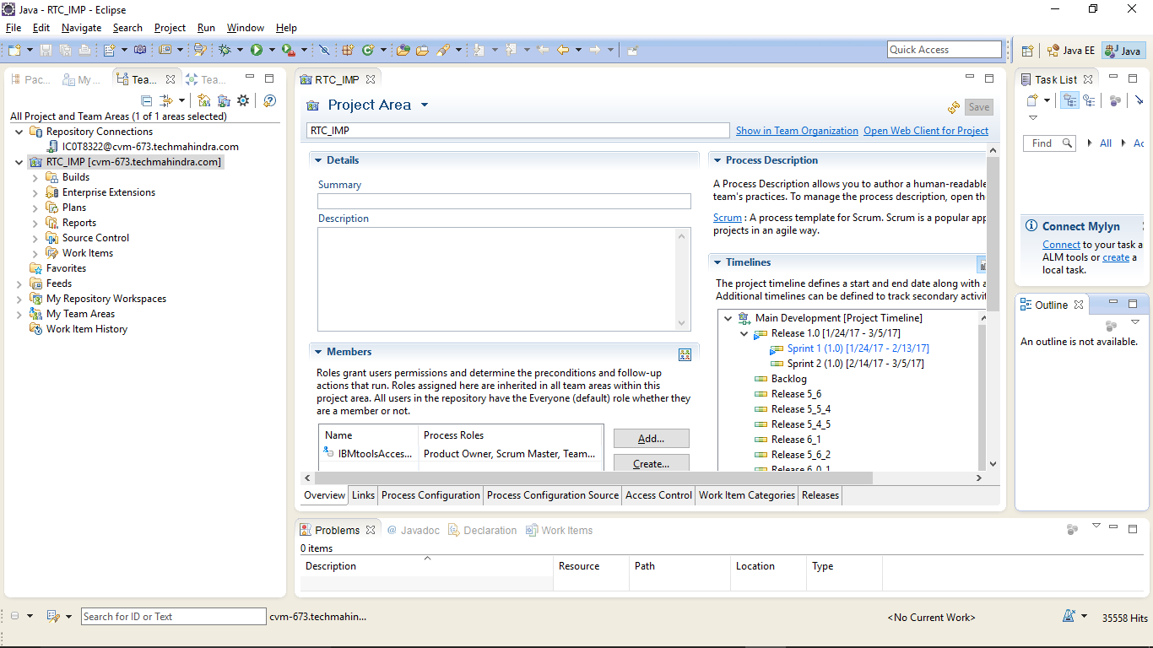

**Other ways to install RTC Client:**

Installing the Rational Team Concert Eclipse client by using Installation Manager

<https://jazz.net/help-dev/clm/index.jsp?topic=%2Fcom.ibm.jazz.install.doc%2Ftopics%2Ft_client_installation.html>

Installing the Rational Team Concert Eclipse client from a .zip file

<https://jazz.net/help-dev/clm/index.jsp?topic=%2Fcom.ibm.jazz.install.doc%2Ftopics%2Ft_client_installation.html>

Installing Rational Team Concert Client for Microsoft Visual Studio IDE

<https://jazz.net/help-dev/clm/index.jsp?topic=%2Fcom.ibm.jazz.install.doc%2Ftopics%2Ft_client_installation.html>

Installing Rational Team Concert Shell

<https://jazz.net/help-dev/clm/index.jsp?topic=%2Fcom.ibm.jazz.install.doc%2Ftopics%2Ft_client_installation.html>

Installing Rational Team Concert MS-SCCI Provider

<https://jazz.net/help-dev/clm/index.jsp?topic=%2Fcom.ibm.jazz.install.doc%2Ftopics%2Ft_client_installation.html>

Connecting the Rational Team Concert Eclipse client to the server

https://jazz.net/help-dev/clm/index.jsp?topic=%2Fcom.ibm.jazz.install.doc%2Ftopics%2Ft_client_installation.html